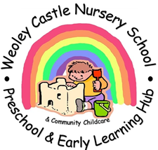
Parent feedback
2022 - 2023

Dear Parents and Carers
Thank you for joining us at our celebration evenings. We have shared a really happy year with you all so far and are so pleased that you are enjoying coming to nursery school.
You all felt that your children had made good progress while they have been here. You told us that your children had become more confident and were comfortable to come to nursery each day. You felt that they had really come on and were more talkative.
We are pleased to hear that you are happy with how we keep you informed and that you feel comfortable to talk with staff at any time. You told us how much you enjoy using the online portal and being able to see what your child has been learning. We are glad that we could offer a workshop about online learning and it was lovely to welcome those parents who joined us from preschool and nursery school.
It was lovely to hear about the activities that your children enjoy most. You told us they love going to the woods, making new friends, playing outside, taking part in shared experiences, the visit to Dudley zoo, meeting Santa, singing, sharing nursery rhymes and stories and reading. In fact, “just about everything”!
We are glad that you all feel well supported by our staff and the systems and processes we have in place. This is such an important aspect of every day here at Weoley. We always want to listen to your views and suggestions and make further improvements where we can.
Lovely to hear that you would all recommend us to other families. You told us that all of our staff are friendly and approachable. You find us kind and caring and the children love coming here. You feel we look after you all as well as your children. It was so wonderful to hear that coming here feels like family. You would recommend us for how happy your children are and how much they have learned. You really value the regular updates about your children.

Thank you all for your support and for placing your trust in us to take care of your little ones and for all of the wonderful and magical moments we share together.
Lesley and the team at Weoley Castle x

